# OUPUT FOR ALL 40 PROGRAMS

NAME: A **Shree ram ragavender**

REG NO:**192124032**

SUBJECT: **QUERY PROCESSING**

CODE: **DSA0502**

**1.Write a Pandas program to select distinct department id from**

**employees file.**

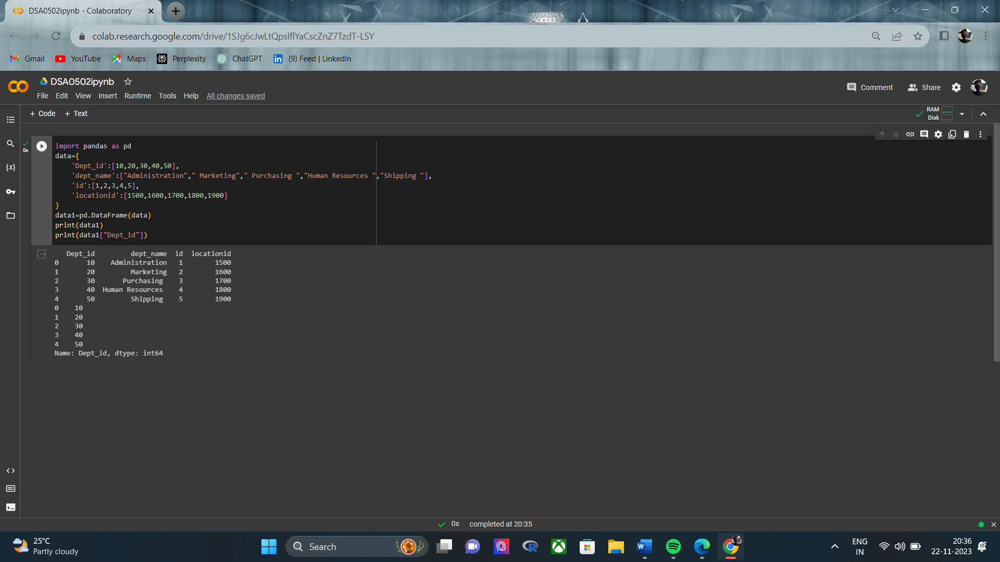

**2. Write a Pandas program to display the ID for those employees who did two or more jobs in the past.**

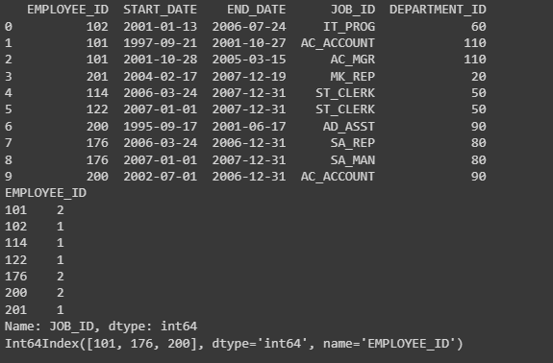

**3. Write a Pandas program to display the details of jobs in descending sequence on job title.**

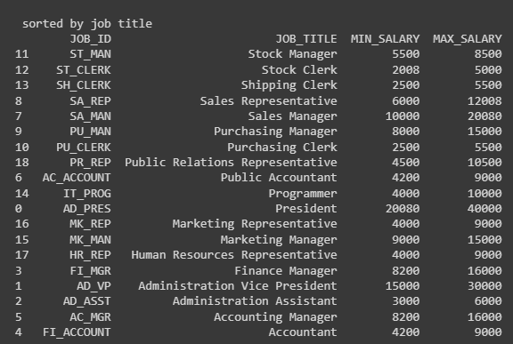

**4. Write a Pandas program to create a line plot of the historical stock prices of Alphabet Inc. between two specific dates**.

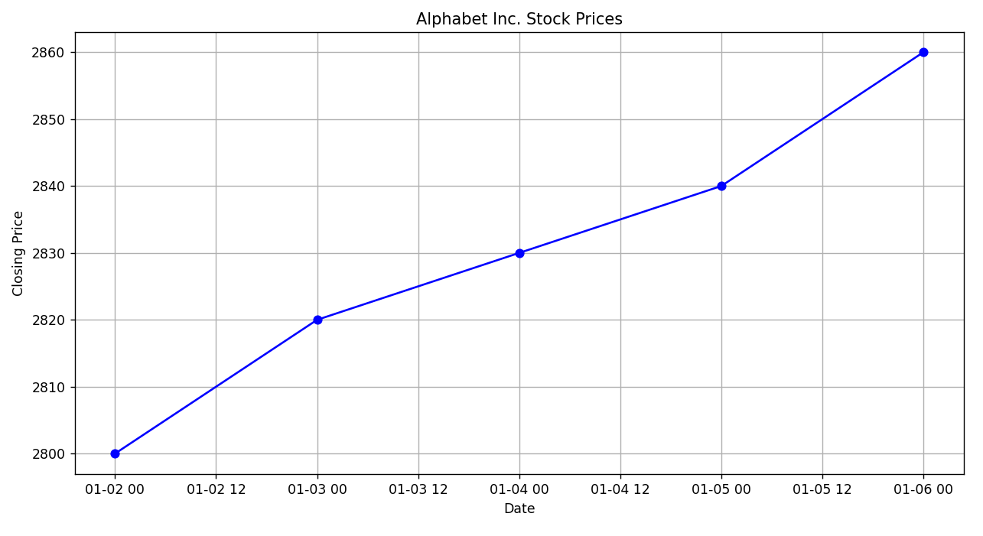

**5.Write a Pandas program to create a bar plot of the trading volume of Alphabet Inc. stock between two specific dates.**

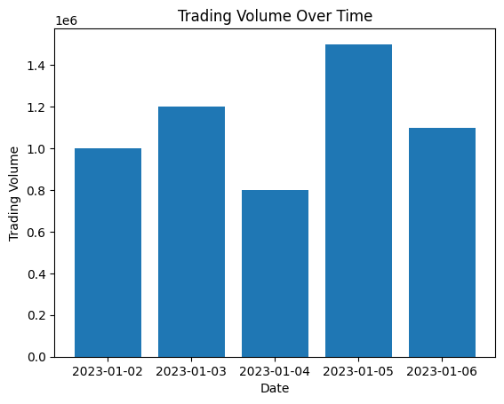

**6**. **Write a Pandas program to create a scatter plot of the trading volume/stock prices of Alphabet Inc. stock between two specific dates.**

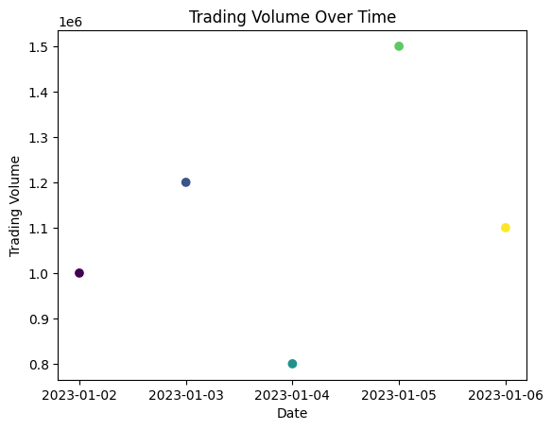

**7. Write a Pandas program to create a Pivot table and find the maximum and minimum sale value of the items.(refer sales_data table)**

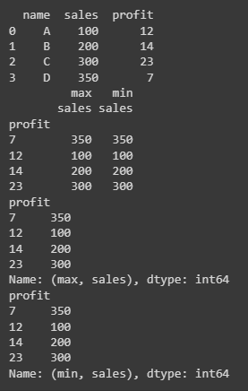

**8. Write a Pandas program to create a Pivot table and find the item wise unit sold. .(refer sales_data table).**

**9. Write a Pandas program to create a Pivot table and find the total sale amount region wise, manager wise, salesman wise. . (refer sales data table)**

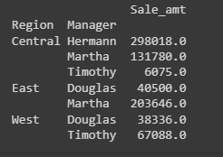

**10. Create a data frame of ten rows, four columns with random values. Write a Pandas program to highlight the negative numbers red and positive numbers black.**

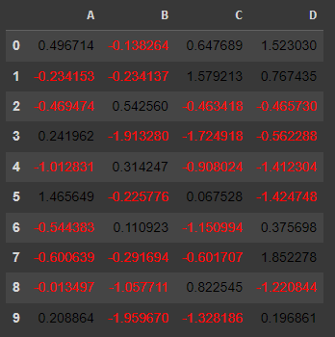

**11.. Create a data frame of ten rows, four columns with random values. Convert some values to nan values. Write a Pandas program which will highlight the nan values.**

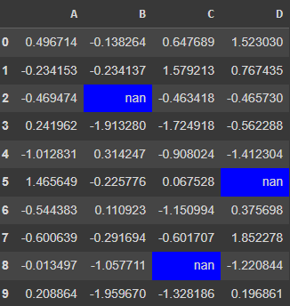

**12. Create a data frame of ten rows, four columns with random values. Write a Pandas program to set dataframe background Color black and font color yellow.**

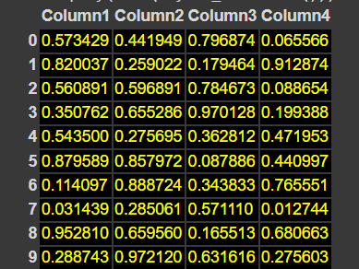

**13. Write a Pandas program to detect missing values of a given DataFrame. Display True or False.**

**14. . Write a Pandas program to find and replace the missing values in a given DataFrame which do not have any valuable information.**

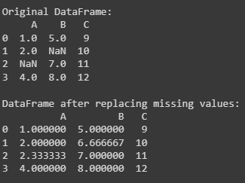

**15.. Write a Pandas program to keep the rows with at least 2 NaN values in a given DataFrame.**

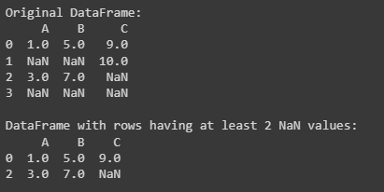

**16. Write a Pandas program to split the following data frame into groups based on school code. Also check the type of Group By object.**

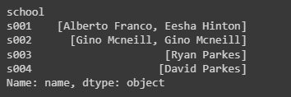

**17.Write a Pandas program to split the following dataframe by school code and get mean, min, and max value of age for each school.**

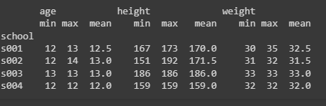

**18.Write a Pandas program to split the following given dataframe into groups based on school code and class.**

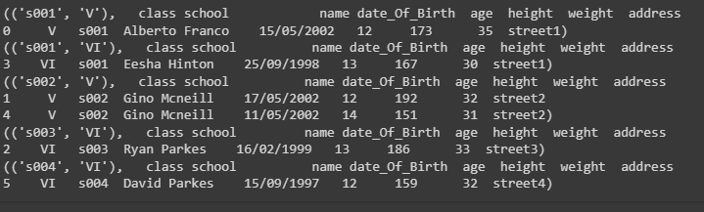

**19.Write a Pandas program to display the dimensions or shape of the World alcohol consumption dataset. Also extract the column names from the dataset.**



**20. Write a Pandas program to find the index of a given substring of a DataFrame column.**

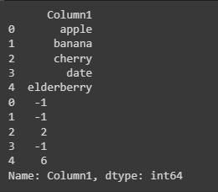

**21. Write a Pandas program to swap the cases of a specified character column in a given DataFrame.**

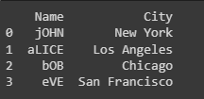

**22.** **Write a Python program to draw a line with suitable label in the x axis, y axis and a title.**

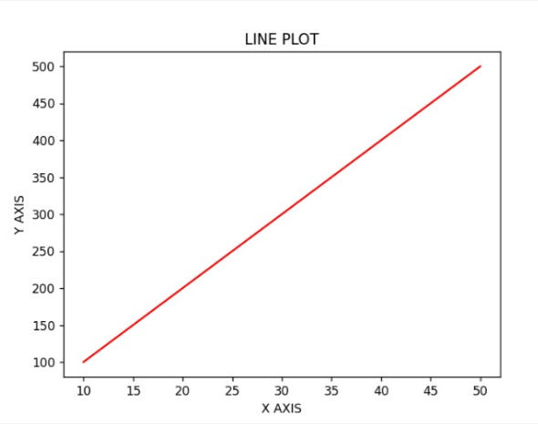

**23.Write a Python program to draw a line using given axis values taken from a text file, with suitable label in the x axis, y axis and a title.**

**24. Write a Python program to draw line charts of the financial data of Alphabet Inc. between October 3, 2016 to October 7, 2016.**

**25. Write a Python program to plot two or more lines with legends, different widths and colours.**

**26.** **Write a Python program to create multiple plots.**

**27.Write a Python programming to display a bar chart of the popularity of programming Languages.**

**28. Write a Python programming to display a horizontal bar chart of the popularity of programming Languages.**

**29.** **Write a Python programming to display a bar chart of the popularity of programming Languages. Use different color for each bar**.

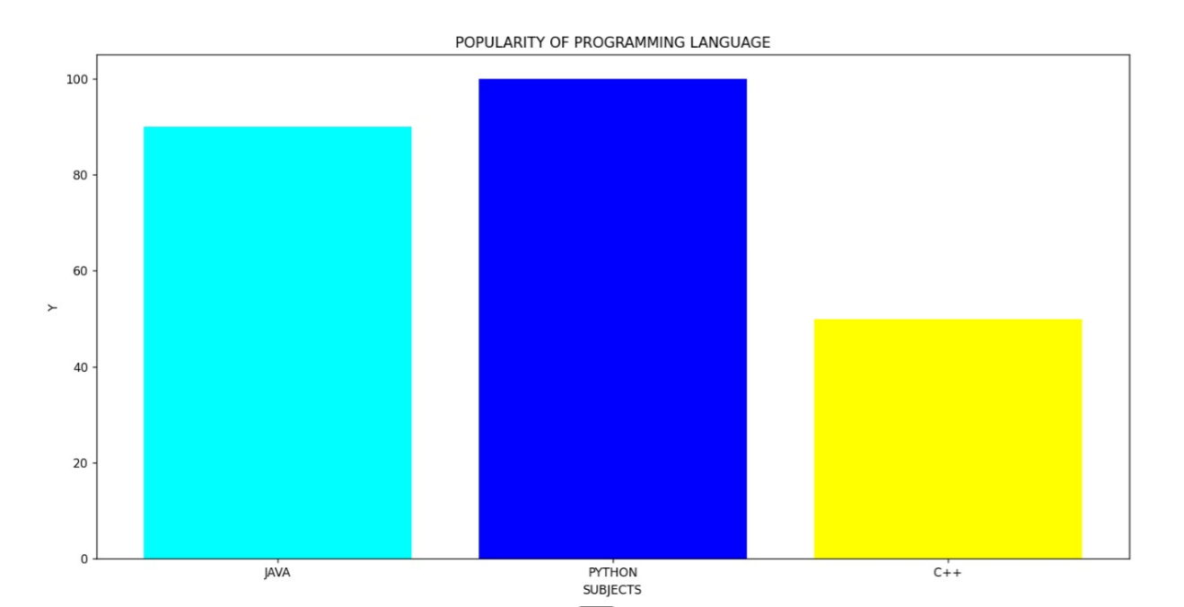

**30.** **Write a Python program to create bar plot of scores by group and gender. Use multiple X values on the same chart for men and women.**

**31.** **Write a Python program to create a stacked bar plot with error bars.**

**32.** **Write a Python program to draw a scatter graph taking a random distribution in X and Y and plotted against each other.**

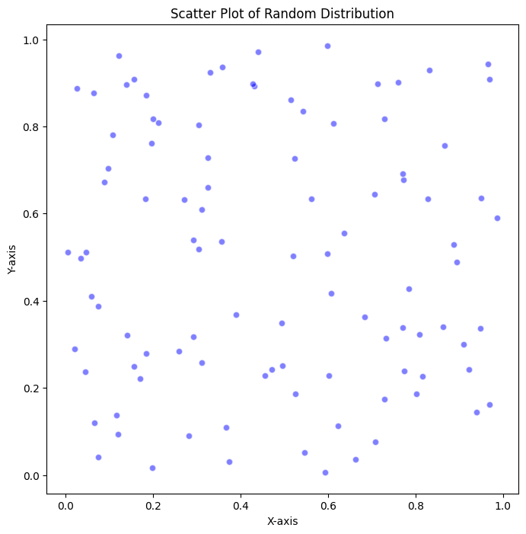

**33.** **Write a Python program to draw a scatter plot with empty circles taking a random distribution in X and Y and plotted against each other.**

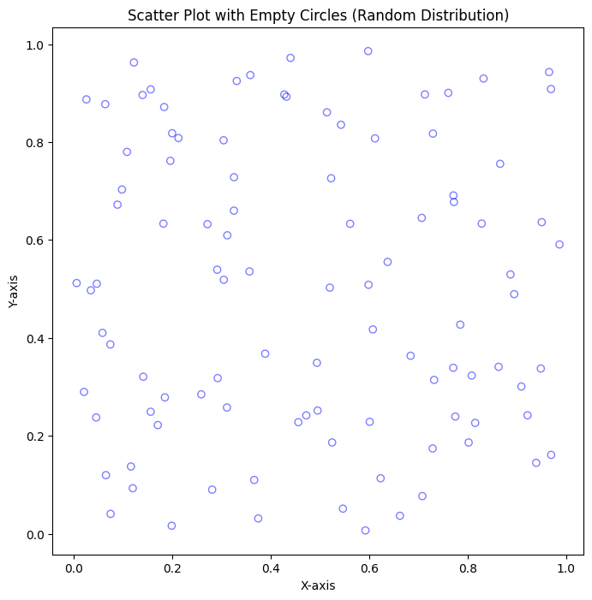

**34.** **Write a Python program to draw a scatter plot using random distributions to generate balls of different sizes.**

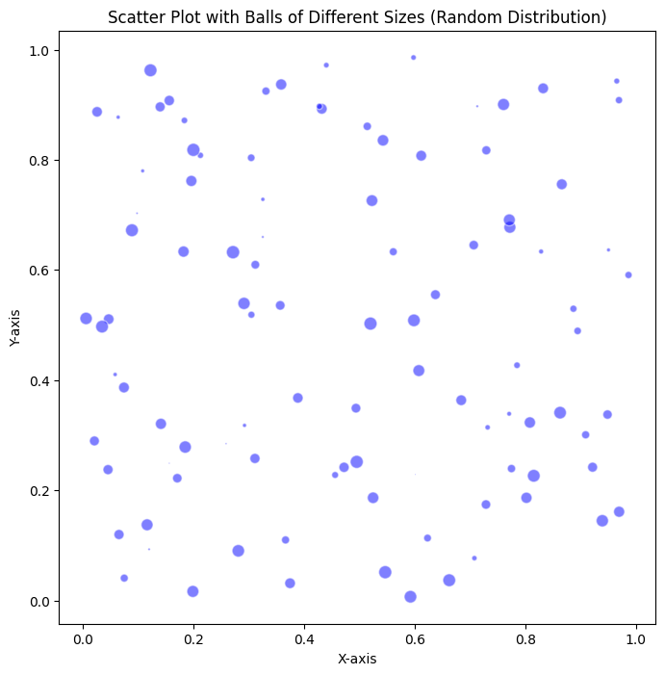

**35. Write a Python program to draw a scatter plot comparing two subject marks of Mathematics and Science. Use marks of 10 students.**

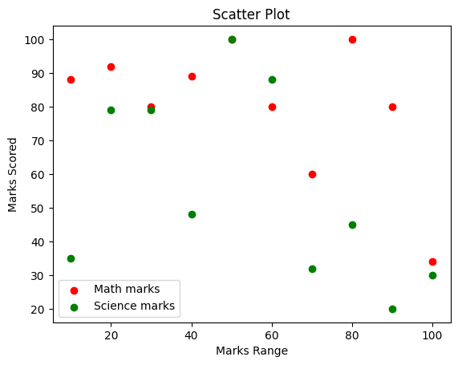

**36.Write a Python program to draw a scatter plot for three different groups comparing weights and heights.**

**37.Write a Pandas program to create a dataframe from a dictionary and display it.**

**38. Write a Pandas program to create and display a DataFrame from a specified dictionary data which has the index labels.**

**39. Write a Pandas program to get the first 3 rows of a given DataFrame.**

**40. Write a Pandas program to select the 'name' and 'score' columns from the following DataFrame.**

